TASK RECORD
NAME: VIKASINI.K
DEPARTMENT: B. Tech CSE (Artificial Intelligence and Data Science)
COLLEGE: Vels institute of science, Technology and Advanced studies
INTERNSHIP ROLE: Data Analyst
TASK: Linux user management commands.
Task Description:
The main purpose of this task is to understand how users and groups are managed in Linux. I also learned how to check a user's group, add a user to the sudo group, create a new group, and delete users or groups using the terminal.
Commands / Tools Used:
userdel, userdel -r, groups, groupadd, usermod, and groupdel.
Commands practiced:
- sudo userdel name - Deletes the user from the Linux system.
- sudo userdel -r name - Deletes user and also removes the user's home directory and files.
- groups name - Shows the groups to which user belongs.
- sudo groupadd name - Creates a new group user named.
- sudo usermod -aG sudo name - Adds the user to the sudo group.
- groups - Checks the groups that user belongs to.
- sudo groupdel name - Deletes the group named user.

INTRODUCTION:

Linux provides different commands to manage users and groups. These commands are useful when working with multiple users in a Linux system. We can create users, check their groups, add users to groups, and delete users when they are no longer needed.

OUTPUT:

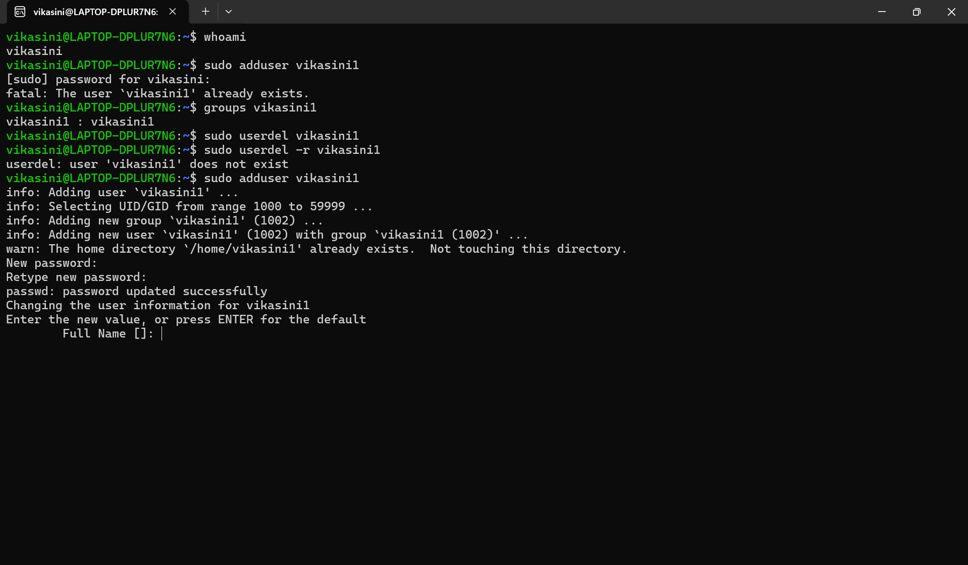
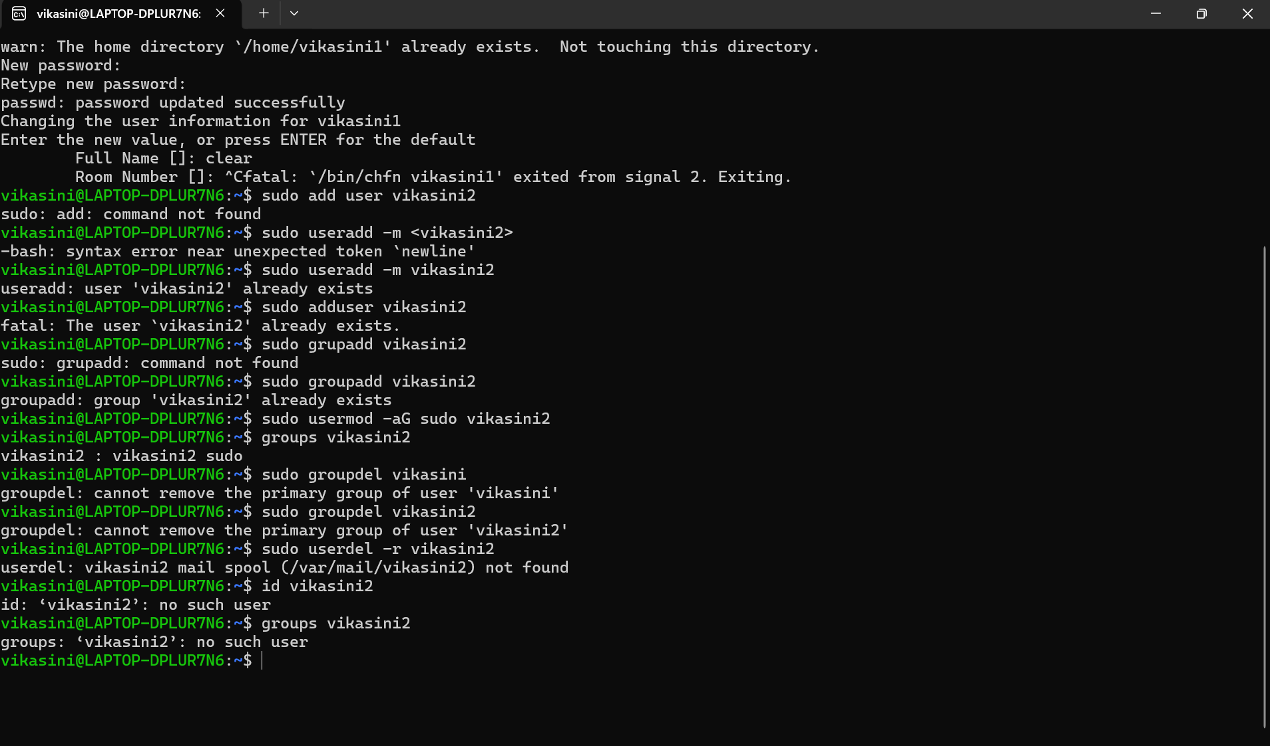

PROBLEMS FACED:
While practicing the Linux commands, I faced some small problems. At first, I tried to create a user that was already present, so I got an error saying that the user already exists. I also typed some commands incorrectly, like add user instead of adduser and groupadd incorrectly.
Another problem I faced was while deleting a group. Linux showed an error because the group was the primary group of the user. I understood that a primary group cannot be deleted while it is still connected to that user.
I also used Ctrl + C while creating a user, which stopped the user creation process. After that, I learned how to properly complete the adduser steps by pressing Enter for the optional details.
These errors helped me understand the commands better because I learned what each error means and how to correct it.
CONCLUSION:
From this task, I learned some basic Linux commands for managing users and groups. I practiced creating users, checking their groups, adding users to the sudo group, and deleting users and groups.

